HOW TO SHIP YOUR BOTTLES TO THE IWSC USING AN
AN INDEPENDENT COURIER

If you cannot ship your samples using our consolidated service, please follow these instructions.
- Samples should be sent using a courier service if being sent internationally – using a postal service (e.g. Parcelforce, Chronopost, La Poste) is not recommended as this will often cause delays or failed deliveries with customs clearance. For international deliveries, we recommend using an international courier such as DHL Express, UPS or FedEx
- A commercial invoice is needed for all entries as part of the customs clearance process – please click for our wine template and our spirits/alternative drinks template. Please list all samples as having a value of 1 EUR / 1 USD per bottle, or 0 EUR if sending from France (this is for customs purposes)
- The invoice must be fixed to the outside of the box and copies handed to the courier.
- Please list entries as: Samples for Tasting – No commercial value
- Please send all samples to: IWSC C/O SWS, Unit 10 Dana Trading Estate, Transfesa Rd, Paddock Wood, Kent, TN12 6UT, UK
- Make sure all UK customs and duties are payable by the sender. IWSC will not accept samples with duty and VAT owing.
- All samples must be sent with incoterms DDP – Delivered Duty Paid
- If you are asked for an EORI code, please use IWSC VAT no. 853 914 212
If you have any further questions about shipping your bottles, please get in touch via email at info@iwsc.net
Filling in the Airway Bills for Direct Shipping

DHL
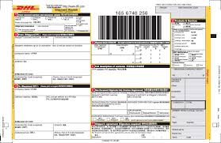
Please tick shipper pays all duties and taxes here on the form.
FEDEX
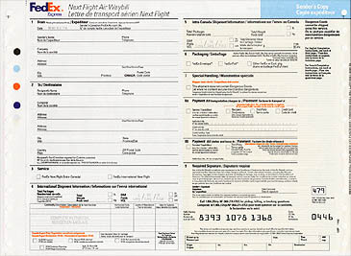
Please tick shipper pays all duties and taxes.

UPS
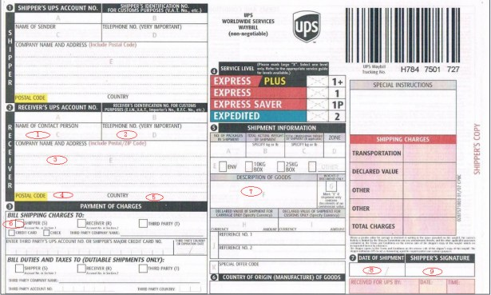
Please tick Shipper pays all duties and taxes.

