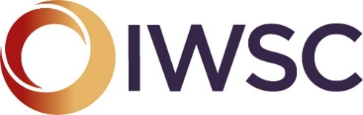 | Emerging Talent in the Hospitality Industry  Sponsored by Conzorzio Prosecco Conegliano Valdobiadenne Superiore

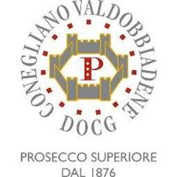
Nomination Form 2021

Do you know someone who is passionate about the customer experience? Are they the best behind the bar? The superior Sommelier? This trophy is awarded to someone who demonstrates a real dedication, passion and style to their role within the hospitality industry. If you know someone who is disrupting the norms, behind a bar, front of house or redefining the way customers interact with drinks, then this is the award for them.
If you wish to nominate someone, please fill in the form below.

Please return to Kirsten.Ferrone@iwsc.net

All nominated must be submitted no later than the 5th March 2021.

NOMINEE’S INFORMATION
Contact name:
Address:
Post code
Phone:

NOMINATOR’S INFORMATION
Contact Name:
Company (if applicable):
Phone: |  | Email:

ABOUT THE PERSON
What is the reason for your nomination, why do they deserve this award? (max 300 words)

