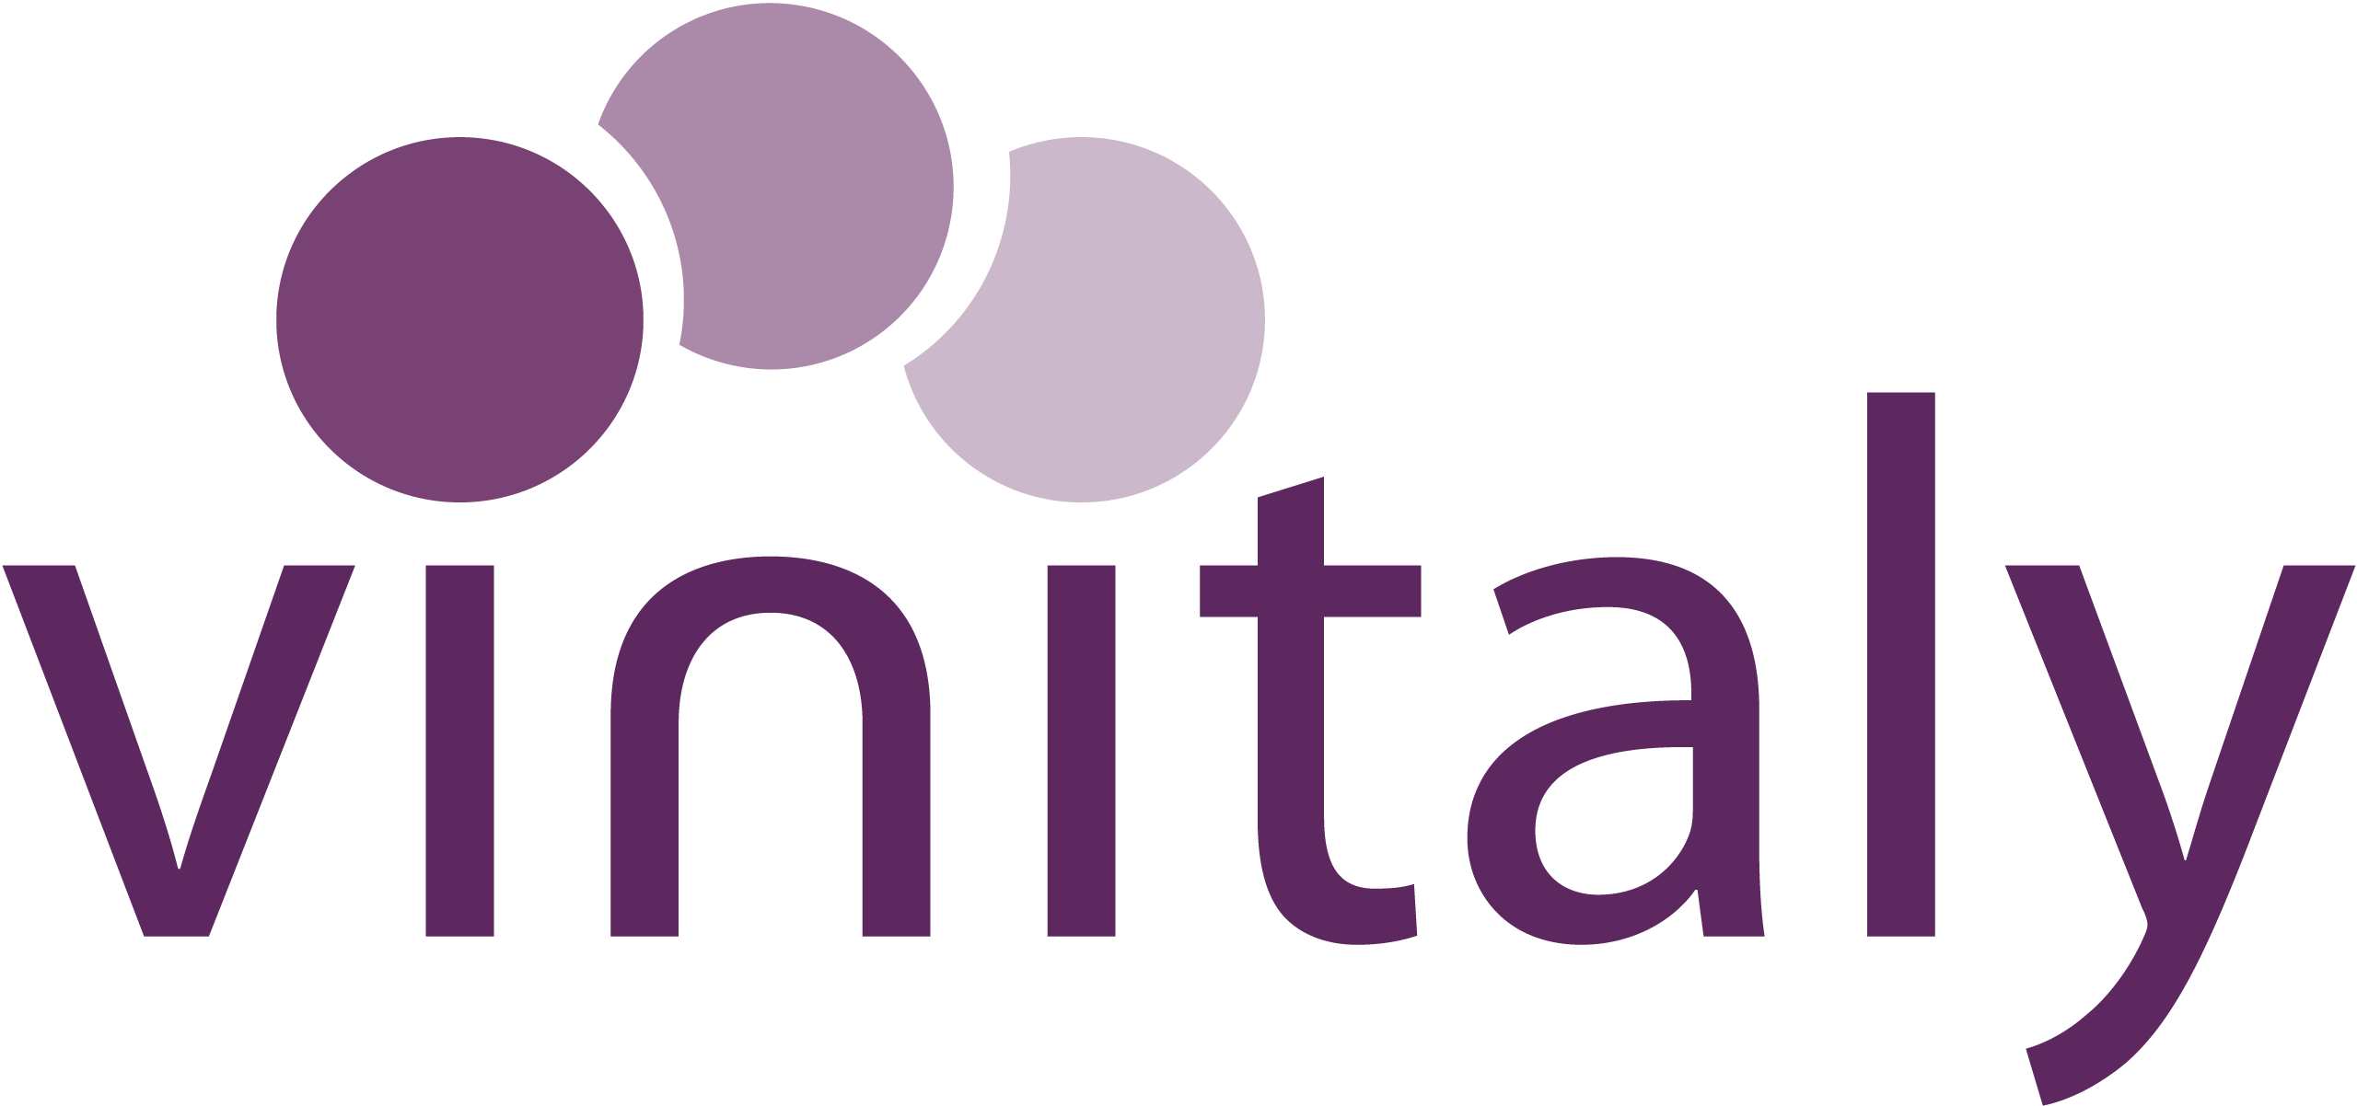
IWSC Wine Communicator of the Year
Sponsored by Veronafiere, organisers of Vinitaly
2022 Entry Form

The hunt is on to find the 2022 IWSC Wine Communicator. Entries are now open for the award that recognises the very finest talent in wine communication.
Organised by the IWSC, in partnership with Veronafiere, organisers of Vinitaly, the world’s largest wine trade show, the competition is open to individuals or organisations whose communication skills have made an exceptional contribution towards the promotion of wine.
The widely regarded accolade is open to entrants from all over the globe, across the worlds of publishing, journalism, social media, broadcasting and education, and is judged by a panel of experts in the field.
Entry is free of charge. The award will be based on the achievement in the past 12 months, between the period of October 2020 and September 2021.
The deadline for entry is Friday 29th October and a shortlist of entrants will be shared the last week of October. The winner will be announced as part of the virtual awards ceremony on 5th November.
Following the announcement, the IWSC will look forward to working closely with the winner in a program of activations throughout the year including hosting a masterclass at Vinitaly in Verona in April 2022 and producing features in the IWSC’s sister publication, Club Oenologique.
Good luck.
Submitting your entry:
Please return this completed questionnaire to Kirsten.Ferrone@iwsc.net by Friday 29th October 2021.

NOMINEE’S CONTACT INFORMATION
Full name:
Address:
Social media handle(s):
Phone: |  | Email

ABOUT YOU
Biography

YOUR ACHIEVEMENTS
List of notable achievements

WHY YOU?
Why would you like to be the 2022 IWSC Wine Communicator?

